question_2.R

Nadim

Wed Feb 13 19:41:57 2019

library(sem)

## Warning: package 'sem' was built under R version 3.5.2

lt <- readMoments("EverittEx5.5.txt", diag = T)  
R <- (lt + t(lt)) - diag(1, 6)  
colnames(R) <- c("French", "English", "History", "Arithmetic", "Algebra", "Geometry")  
rownames(R) <- c("French", "English", "History", "Arithmetic", "Algebra", "Geometry")  
  
library(corrplot)

## Warning: package 'corrplot' was built under R version 3.5.2

## corrplot 0.84 loaded

library(psych)

## Warning: package 'psych' was built under R version 3.5.2

corrplot(R)

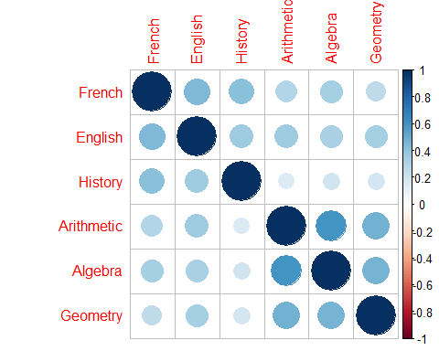

#model fit-1  
model.1<-fa(r=R,nfactors = 2,n.obs = 220,fm = "ml",rotate = "none")  
model.1$loadings

##   
## Loadings:  
## ML1 ML2   
## French 0.558 0.425  
## English 0.569 0.286  
## History 0.392 0.450  
## Arithmetic 0.738 -0.279  
## Algebra 0.718 -0.209  
## Geometry 0.595 -0.133  
##   
## ML1 ML2  
## SS loadings 2.204 0.603  
## Proportion Var 0.367 0.101  
## Cumulative Var 0.367 0.468

###We can see that factors here are not very much interpretable  
#model fit-2  
model.2<-fa(r=R,nfactors = 2,n.obs = 220,fm = "ml",rotate = "varimax")  
model.2$loadings

##   
## Loadings:  
## ML1 ML2   
## French 0.233 0.661  
## English 0.319 0.551  
## History 0.591  
## Arithmetic 0.770 0.172  
## Algebra 0.715 0.220  
## Geometry 0.570 0.215  
##   
## ML1 ML2  
## SS loadings 1.593 1.215  
## Proportion Var 0.265 0.202  
## Cumulative Var 0.265 0.468

####after rotation of the factors we can make clear interpretations that  
####the first factor focuses more on the arthmetic abilities and the second factor  
#### focusses more on the linguistic abilities  
factanal(covmat =R,factors = 2,n.obs = 220)#R:

##   
## Call:  
## factanal(factors = 2, covmat = R, n.obs = 220)  
##   
## Uniquenesses:  
## French English History Arithmetic Algebra Geometry   
## 0.508 0.595 0.644 0.377 0.440 0.628   
##   
## Loadings:  
## Factor1 Factor2  
## French 0.233 0.661   
## English 0.319 0.551   
## History 0.591   
## Arithmetic 0.770 0.172   
## Algebra 0.715 0.220   
## Geometry 0.570 0.215   
##   
## Factor1 Factor2  
## SS loadings 1.593 1.215  
## Proportion Var 0.265 0.202  
## Cumulative Var 0.265 0.468  
##   
## Test of the hypothesis that 2 factors are sufficient.  
## The chi square statistic is 2.18 on 4 degrees of freedom.  
## The p-value is 0.703

#### From the P-value we can clearly see that that the model is a good fit for the data  
#### since p>0.05(by a very huge margin)